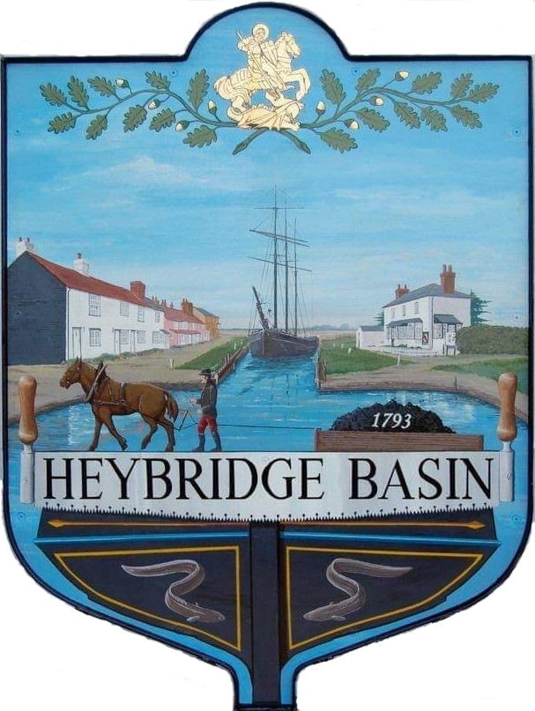

HEYBRIDGE BASIN PARISH COUNCIL

Minutes of the Extraordinary meeting of Heybridge Basin Parish Council held on Tuesday 6th February 2024 at 19.30pm, at St George’s Community Room.

PRESENT

In the Chair: R. Bryson (Vice) Absent: 0

Councillors: C. Edmond Apologies: 3
S. Sjollema
G. Howat Public: 10

Officers: G. Lake – Clerk District Councillors: P. Spenceley

In the absence of the Chair, Cllr Hodges, the Vice Chair Cllr Bryson chaired the meeting.

23/172 Chair’s Welcome
Cllr Bryson opened and welcomed everyone to the meeting and advised that the Clerk was recording the meeting for the purpose of the Minutes which would be published on the website by the end of the week.

23/173 Apologies for Absence.
Cllrs Hodges, Hobden and Swann.

23/174 To receive Declarations of Interest in accordance with the Council’s Code of Conduct and with section 106 of the Local Government Finance Act 1992.
Cllr Howat – Non-Pecuniary – HBCSA, C. Edmond – Non-Pecuniary – Essex Waterways and Director of Cloughton Court Management Company Ltd and Cllr Bryson – Non-Pecuniary – Relatives who work within St Peters, Maldon.

23/171 St Peters Community Hospital
  - To receive a presentation from District Cllr Spenceley.
A presentation with details on the proposed changes to the medical services within Maldon was received.
  - Public Participation
Members of the public will be given an opportunity to put forward their question(s) or statement.

Cllr Spenceley answered the below questions:

- I had heard that we were going to have various hubs in Maldon, maybe for scans, X-Rays and blood tests, so this is definitely not happening?
No, it could be, and this is what we’ve got to say. When you go to the survey, there are some tick boxes for you to rate the ideas, but also free text boxes to write in what you think about that question. You’re invited to make suggestions if you have them about what could happen, and if you know various sites where this could happen then feel free to mention them.

- We know what is on the ground floor, what is on the other two floors?
I understand that stroke rehabilitation was upstairs. They are saying first floor is so unsound that they can’t take heavy people in wheelchairs up there as the floor would collapse.

- I wrote to them and got a reply from them about how its 150 years old and can’t be maintained, are we able to request the budget they have spent on it recently in the last few years to if they have been trying to maintain it or running it down on purpose?
That’s an interesting one, you could put into the consultation survey. If you want an answer you would need to go onto the ICB website and look at where you can send questions in. I have been hearing different things, that some rooms inside were refurbished recently, but I don’t think they have been pumping huge amounts of money into the structure. I have heard that the lift is so old, the company won’t service it anymore.

They spent money on the roof, which started leaking straight away, but didn’t get the contractors back in to repair.
It would cost £18.6 million to renovate the hospital, and you could make that argument on the survey, but it is important to focus on keeping the services within Maldon. It’s a good idea to make clear your views about keeping the hospital open as this is about your views but if they’re not going to do it, they’re not going to do it.

One of arguments they are making is that even if they renovated it, it wouldn’t be of the standard they need for modern use and the sewers underneath are problematic.

- What is the new unit they have built at St Peters on the left-hand side as you drive out?
That’s the nursing home. Consultation says that’s not part of the hospital.

- Have any of the services left already?
Yes, the birthing unit has gone, except the midwives and midwifery assistances are still based there. This is where it is complicated – It’s one thing to say births will happen elsewhere, but what about the antenatal and postnatal care services? The midwives use St Peters as a base to go out to the Dengie and other areas. District nurses are there too.

- Who makes the final recommendation and decision?
The Mid and South Essex Integrated Care Board (ICB) are responsible for delivering the services and the building is owned by The Mid and South Essex Hospital Foundation Trust. The ICB has to take the consultation results to the national NHS. The ICB will need to make a business case out of the consultation responses.

- What are the statutory obligations on these people and this board to provide services to communities? Are there any issues around distance, that people have to travel, population sizes that makes it an obligation on them to provide these services?
. If you read the consultation, you will see what the ICB is proposing to do., They have laid out the figures clearly. They make the argument that their systems will have 25% less follow up appointments which will greatly affect the need for St Peters, but it doesn’t say how. In other words, the ICB is saying that the proposals they make in the consultation will best serve the people of the area. The consultation survey is a chance for you to have your say about that.

- I was told that we would be expected to go to Broomfield hospital for blood tests and other things.
I have some faith that blood tests will be kept local, but it’s important to have your say about the services that are important to you and your family. The survey actually asks that question.

We go to Broomfield now for a lot of things, and you can’t park. There are lots of houses being built near Broomfield and the Noth Chelmsford area, and a new trainline – They won’t be able to cope.
If these are your view, then these are all things you must say in the consultation.

People from around here and further like Bradwell will have to take a car to get to Broomfield, and you can’t park, have they got more parking areas?
I don’t know whether they will create one – I don’t have any information on that.

- Is there anything in our Local plan about private hospitals?
No, there is nothing with regard to private hospitals. They do tend to refer some NHS Patients to them in areas where they exist or even from here, and we don’t have that option locally here. It’s another point to make if you wish to.

Cllr Bryson thanked Cllr Spenceley for her presentation and answering questions. Cllr Bryson urged people to spread the word to as many people as possible to complete the consultation survey.

  - To note actions resolved at previous meeting and consider any further actions to be taken in relation to the consultation.
It was resolved at the previous meeting:
- For the Clerk to order paper copies of the survey.
- For the Clerk to organise timed slots for members to help residents complete the survey.
- For the Clerk to advertise the public meeting on the 9th February at The Plume School at 7pm.
- For the Clerk to upload the QR Code onto the Council’s website and Facebook page.
- To send a member of the Council to the 19th March meeting at Maldon Town Hall.

It was resolved for the Clerk to post the QR Code onto the noticeboards.
It was resolved that Cllrs Edmond, Bryson and Sjollema would represent the Council at the 19th March meeting at Maldon Town Hall and for the Clerk to complete the registration form.

There being no further business the meeting closed at 08:55pm
Provisional Date of the next Council Meeting Tuesday 12th March 2024

Clerk Contact details: clerk@heybridgebasinpc.org.uk
Website: www.heybridgebasin-pc.gov.uk

